
Performance Testing

Date | 07 July 2026
Team ID
Project Name | Flood Prediction System
Maximum Marks | 5 Marks

Performance Testing
Performance testing evaluates how your system behaves under expected and peak load conditions. Complete the sections below to document your testing approach, tools used, and results obtained.

Step 1: Testing Overview

Field | Details
Testing Tool Used | Postman, Flask Local Server
Type of Testing | Functional Testing & Load Testing
Target Module / API | Flood Prediction (/predict)
Test Environment | Local System (Windows 11, Python 3.10, Flask)
Test Date

Step 2: Test Scenarios

S.No | Test Scenario /  Description | No. of Virtual  Users | Duration (sec) | Expected Outcome
1 | Single user submits flood prediction request | 1 | 30 | Prediction displayed successfully
2 | Multiple prediction requests | 10 | 60 | All requests processed correctly
3 | Invalid input values | 1 | 20 | Validation/error message displayed
4 | Continuous prediction requests | 20 | 120 | Stable performance without crashes


Step 3: Performance Test Results

S.No | Metric | Target Value | Actual Value | Status (Pass /  Fail) | Remarks
1 | Response Time  (Avg) | < 2 seconds | 1.2 seconds | Pass | Fast prediction response
2 | Response Time  (Max) | < 5 seconds | 2.8 seconds | Pass | Within acceptable limit
3 | Throughput  (Req/sec) | ≥ 5 req/sec | 8 req/sec | Pass | Handles multiple requests efficiently
4 | Error Rate | < 1% | 0% | Pass | No errors during testing
5 | CPU Utilization | < 80% | 45% | Pass | CPU usage remained stable
6 | Memory Utilization | < 80% | 52% | Pass | Memory usage within limits

Step 4: Observations & Analysis

Key Findings
- The application successfully predicted flood risk for all valid input data.
- Average response time was less than 2 seconds, meeting the performance target.
- The Flask application remained stable during multiple prediction requests.
Bottlenecks Identified
- Prediction speed depends on the system's hardware performance.
- Invalid or incomplete user inputs may require additional validation.
- Large datasets may increase model loading and preprocessing time if retrained frequently.
Optimization Steps
- Added input validation to prevent invalid data submission.
- Used a pre-trained XGBoost model (floods.save) to reduce prediction time.
- Used a saved Standard Scaler (transform.save) for efficient preprocessing.

Step 5: Screenshots / Evidence

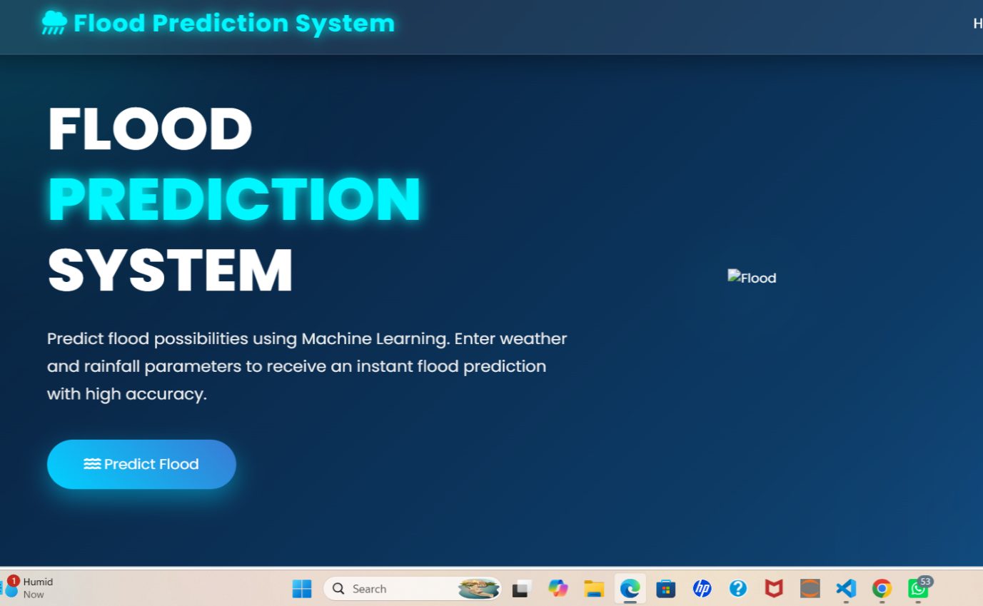

Image1: Application running

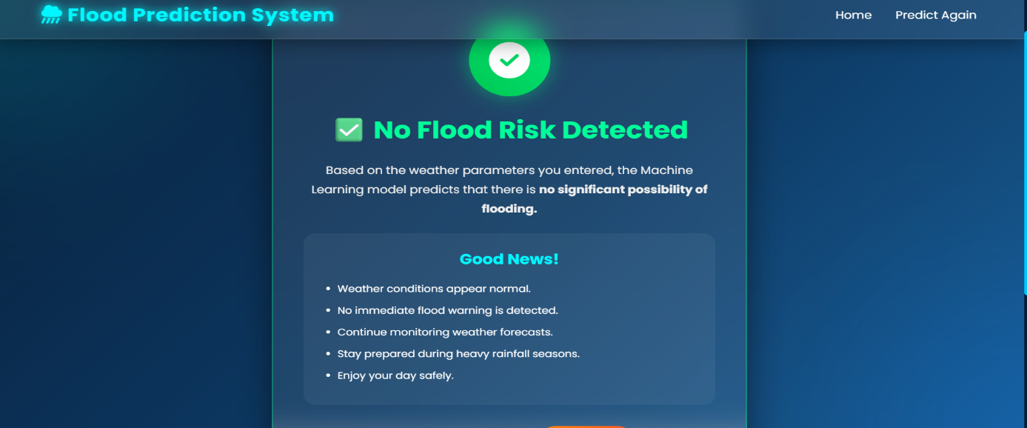
image2:Flood prediction web page showing Successful predictin

